Top 20 Statewide Health Care Occupations for North Carolina

Table 1: NC Employment and Projected Employment in Top 20 Statewide Health Care Occupations, 2018-2023
SOC | Occupation | 2018 Jobs | 2023 Jobs | 2018 - 2023 % Change
29-1141 | Registered Nurses | 102,935 | 110,182 | 7%
31-1014 | Nursing Assistants | 63,247 | 65,127 | 3%
39-9021 | Personal Care Aides | 32,775 | 37,573 | 15%
31-1011 | Home Health Aides | 30,307 | 33,555 | 11%
31-9092 | Medical Assistants | 19,485 | 21,771 | 12%
29-2061 | Licensed Practical and Licensed Vocational Nurses | 18,955 | 19,765 | 4%
43-6013 | Medical Secretaries | 16,269 | 18,078 | 11%
29-1069 | Physicians and Surgeons, All Other | 13,756 | 14,681 | 7%
29-2052 | Pharmacy Technicians | 13,664 | 14,112 | 3%
29-2018 | Clinical Laboratory Technologists and Technicians | 11,646 | 12,740 | 9%
29-2041 | Emergency Medical Technicians and Paramedics | 11,200 | 11,701 | 4%
31-9091 | Dental Assistants | 9,715 | 10,805 | 11%
11-9111 | Medical and Health Services Managers | 9,514 | 10,482 | 10%
29-1051 | Pharmacists | 9,859 | 10,006 | 1%
21-1018 | Substance Abuse, Behavioral Disorder, and Mental Health Counselors | 8,244 | 9,207 | 12%
29-2034 | Radiologic Technologists | 7,449 | 7,970 | 7%
29-2021 | Dental Hygienists | 6,689 | 7,423 | 11%
29-2099 | Health Technologists and Technicians, All Other | 6,446 | 6,776 | 5%
29-1123 | Physical Therapists | 6,139 | 6,775 | 10%
29-1071 | Physician Assistants | 4,994 | 5,696 | 14%
 | Statewide Totals | 403,289 | 434,425 | 8%

Notes on the Data:

EMSI was used to pull the industry and occupational data from the United States Bureau of Labor Statistics. 21 health care industries were identified at the 5-digit NAICS level, including hospitals, physicians’ offices, dental practices, outpatient care centers, home health services, nursing homes and other residential care facilities, public health departments and pharmacies.

After analyzing the industries that should be included in the analysis, the research team identified the occupations that AHEC would include in the analysis. The staffing patterns for the identified industries were pulled, and the research team narrowed the list of occupations to 104 occupations that were targeted as most important to AHEC’s mission. The data includes all people employed in these occupations, including those people who may be employed in non-health care industries. Of these 104 occupations, there were only 5 occupations that were projected to lose employment between 2018 and 2023: respiratory therapy technicians, medical transcriptionists, pharmacy aides, life scientists and biochemists & biophysicists. The other 99 identified occupations are either projected to stay at the same employment levels (3 occupations) or increase employment between 1%-26% (96 occupations). The occupations that were projected to have the highest employment in 2023 in North Carolina comprised the top 20 statewide health care occupations for our study and are captured in table 1.

While these occupations are projected to have the highest employment, the data also indicates that they are sought after by employers in terms of projected job openings and job postings. EMSI uses public data sources to project openings, which include new positions that are created to keep up with additional work and positions that need to be replaced within an occupation when a worker retires or leaves for a different occupation; EMSI uses public data sources, including the US Bureau of Labor Statistics’ replacement rates, to calculate these openings. Job postings include those job openings that employers advertise for on the internet, and these postings are de-duplicated to make sure that each posting is only counted once. True demand for these positions likely falls somewhere between the number of job openings and number of job postings. Image 1 shows the job postings in North Carolina compared to hires for these top 20 occupations from September 2016 through October 2019.

Image 1: Statewide Active Job Postings and Estimated Hires for Top 20 Statewide Occupations, 2016-2019
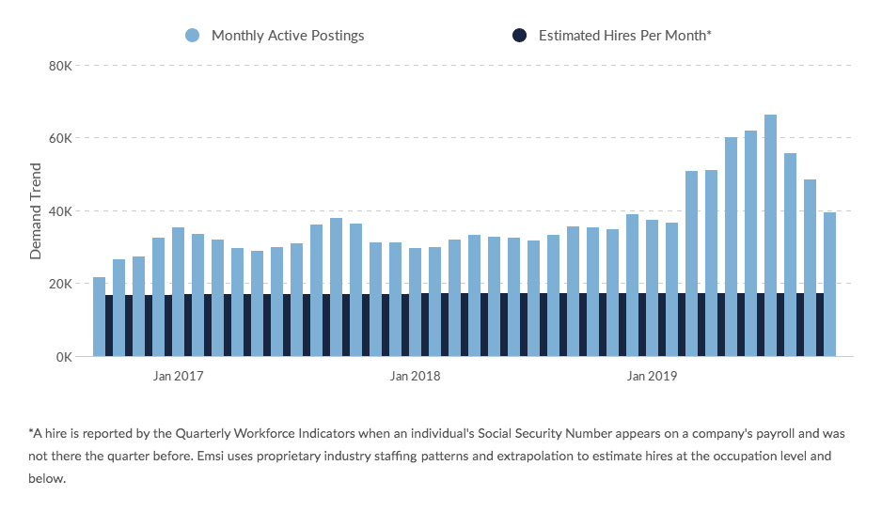

Table 2: North Carolina Top 20 Health Occupations and Descriptions

Within the identified occupations, there is some overlap in definitions and job titles. Please note that the occupational definitions below denote the duties that all workers classified in the occupation must perform. For the “all other” categories, the specific occupations are listed separately.

SOC  Code | Occupation | Standard Occupational Classification (SOC) Definition from US Bureau of Labor Statistics
29-1141 | Registered Nurses | Assess patient health problems and needs, develop and implement nursing care plans, and maintain medical records.
31-1014 | Nursing Assistants | Provide basic patient care under direction of nursing staff.
39-9021 | Personal Care Aides | Assist the elderly, convalescents, or persons with disabilities with daily living activities at the person's home or in a care facility.
31-1011 | Home Health Aides | Provide routine individualized healthcare such as changing bandages and dressing wounds, and applying topical medications to the elderly, convalescents, or persons with disabilities at the patient's home or in a care facility.
31-9092 | Medical Assistants | Perform administrative and certain clinical duties under the direction of a physician.
29-2061 | Licensed Practical and Licensed Vocational Nurses | Care for ill, injured, or convalescing patients or persons with disabilities in hospitals, nursing homes, clinics, private homes, group homes, and similar institutions.
43-6013 | Medical Secretaries | Perform secretarial duties using specific knowledge of medical terminology and hospital, clinic, or laboratory procedures.
29-1069 | Physicians and Surgeons, All Other | All physicians and surgeons not listed separately.  29-1069.01 Allergists and Immunologists  29-1069.02 Dermatologists  29-1069.03 Hospitalists  29-1069.04 Neurologists  29-1069.05 Nuclear Medicine Physicians  29-1069.06 Ophthalmologists  29-1069.07 Pathologists  29-1069.08 Physical Medicine and Rehabilitation Physicians  29-1069.09 Preventive Medicine Physicians  29-1069.10 Radiologists  29-1069.11 Sports Medicine Physicians  29-1069.12 Urologists
29-2052 | Pharmacy Technicians | Prepare medications under the direction of a pharmacist.
29-2011 and 29-2012 combined | Clinical Laboratory Technologists and Technicians | Technologist - Perform complex medical laboratory tests for diagnosis, treatment, and prevention of disease.  Technician - Perform routine medical laboratory tests for the diagnosis, treatment, and prevention of disease.
29-2041 | Emergency Medical Technicians and Paramedics | Assess injuries, administer emergency medical care, and extricate trapped individuals.
31-9091 | Dental Assistants | Assist dentist, set up equipment, prepare patient for treatment, and keep records.
11-9111 | Medical and Health Services Managers | Plan, direct, or coordinate medical and health services in hospitals, clinics, managed care organizations, public health agencies, or similar organizations.
29-1051 | Pharmacists | Dispense drugs prescribed by physicians and other health practitioners and provide information to patients about medications and their use.
21-1018 | Substance Abuse, Behavioral Disorder, and Mental Health Counselors | Counsel and advise individuals, families, or groups to prevent or treat substance abuse problems, behavioral disorders, or a broad range of mental health issues in order to promote optimum mental and emotional health.
29-2034 | Radiologic Technologists | Take x rays and CAT scans or administer nonradioactive materials into patient's blood stream for diagnostic purposes.
29-2021 | Dental Hygienists | Clean teeth and examine oral areas, head, and neck for signs of oral disease.
29-2099 | Health Technologists and Technicians, All Other | All health technologists and technicians not listed separately.  Midwives - Provide prenatal care and childbirth assistance.
29-1123 | Physical Therapists | Assess, plan, organize, and participate in rehabilitative programs that improve mobility, relieve pain, increase strength, and improve or correct disabling conditions resulting from disease or injury.
29-1071 | Physician Assistants | Provide healthcare services typically performed by a physician, under the supervision of a physician.

Standard Occupational Classifications are groups of occupations that were developed by federal government agencies (including Office of Management and Budget, US Bureau of Labor Statistics, Health Resources and Services Administration, Census Bureau, etc.) as a way to compare occupations across industries and groups. Information is collected from individuals and businesses on employment levels and trends, pay and benefits, demographic characteristics, skills required, and many other items; this information is widely used by government, researchers, businesses, public policy makers and others. The data covers all occupations in which work is performed for pay or profit.

Workers are coded to an occupation based on the work performed, but they sometimes fall into more than one occupation. When they do, the worker is placed in the occupation requiring the highest level of skill and then in the occupation in which they spend the most amount of their time. Licensed and unlicensed workers who are performing the same work are classified together unless otherwise specified.

ONET and BLS information for 21-1011, which is a broader category.

