In-Person program
T.E.A.C.H
Teaching Excellence for a Career in Health
An Enrichment Program for High School Students Interested in Careers in Health Care
October 10,2022-
May 8,2023
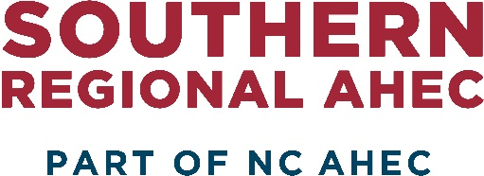
Southern Regional AHEC
1601 Owen Drive (3rd Floor)
Fayetteville, NC 28304
(Across from Cape Fear Valley Medical Center)

Southern Regional AHEC Health Careers
Through the Model State Supported Grant, Southern Regional AHEC (SR-AHEC) provides programs designed to prepare 8th -12th grade and undergraduate students for careers in the health field. With an emphasis on students who are historically underrepresented (minorities, economically and/or educationally disadvantaged, etc.), it is the goal of the NC AHEC program to improve the distribution and retention of health care professionals in the state.

Program Description
Teaching Excellence for A Career in Health (TEACH) is a eight-month pre-professional health enrichment program for high school students in grades 8 through 12. The ultimate goal of TEACH is to serve as an integral component in the North Carolina health education pipeline and to make a significant impact on the number of underrepresented students entering health fields in the region. Hybrid Sessions (participants may attend in person or sign in via ZOOM link)

Eligibility Requirements
To be eligible to participate, students must meet the following criteria:
- Reside in: Bladen, Cumberland, Harnett, Hoke, Moore, Richmond, Robeson, Sampson, or Scotland County.
- Be enrolled in grades 8 through 12;
- Maintain at least a 2.5 GPA;

Activities
TEACH activities include:
- Health science education workshops consisting of lectures emphasizing human anatomy and physiology, information on diseases that affect minority populations, disease treatment and behavior modifications for disease prevention, and hands-on instructions for monitoring body vital signs.
- Health awareness and professional development seminars featuring health career speakers emphasizing awareness of multiculturalism, health disparities, professional health careers, and education programs, and the financial aid and admissions application process to facilitate entry into college.
- Cultural competency, Diversity & Inclusion and Emerging issues in the health profession.
- Collaboration with summer pipeline education enrichment programs such as the one-week virtual summer program for high school students in grades 8 through 12.
Registration
To Register please follow the link below, click on APPLY ONLINE. Eligible participants will be notified via email by September 30, 2022. Scholarships available for first 20 eligible students.
- https://www.southernregionalahec.org/teach/

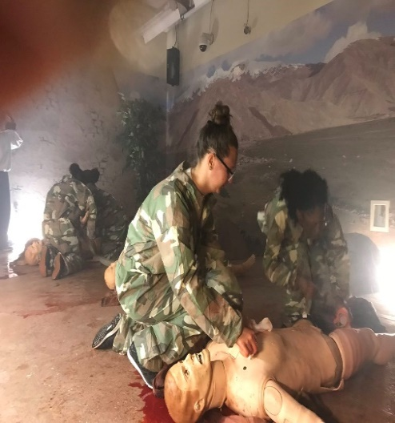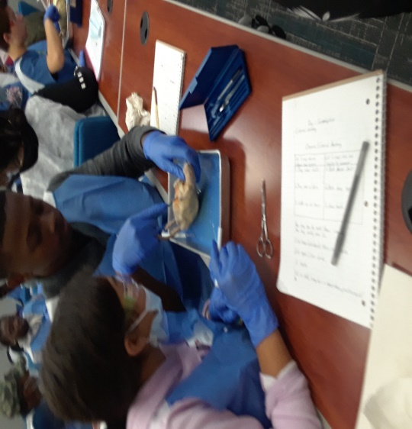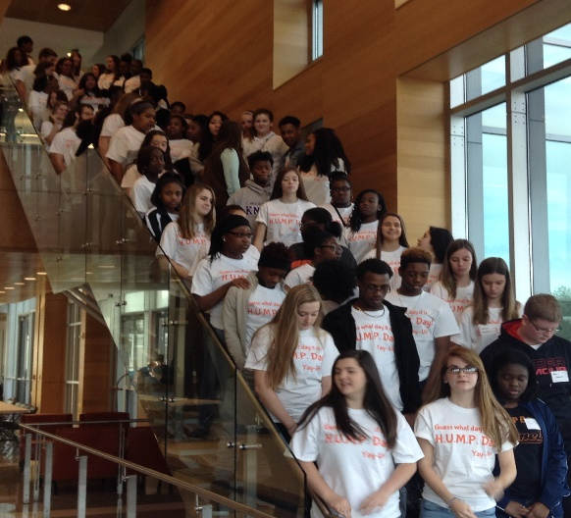

TEACH College events/tours & Seminars: FREE with T.EA.C.H enrolled students
Events: 1. Health Careers Maternal Health Symposium-July 18-19, 2023
2. HUMP Day @ Campbell University (Helping students Understand the Medical Profession)-March 18, 2023
3. East Carolina University Brody School of Medicine Pre-Health Professions Conference (Date pending)

Objectives: Three outings per session Fall and Spring. This event is sponsored by the North Carolina Health Careers Access Program.

Certifications
American Heart Association- Heart saver CPR, First Aid, AED

Fee
$100 per student; Registration must be received by September 12, 2022. You may submit the fee in (4) payments of $25. Students will also be registered for the Passport to Health Care program as well as Youth Health Service Corporation Presidential Award program
Credit
Participants who attend 100% of the program will receive a certificate upon completion, which is recognized by the University of North Carolina College System.

Substitutes/Refunds/Transfers
Participants who register for the program and are not able to attend, may send a qualified substitute; or if canceled within 48 business hours before the program, receive a voucher for 100% of the registration fee for use at a future SR-AHEC program.

Tonya Burney, MS,CPD
Director of Health Careers
(910) 678-7201 / tonya.burney@sr-ahec.org
Ashley Diehm, Program registrar
910-678-7226/ ashley.diehm@sr-ahec.org

